# Git

A **TFS git** repository is used as the version control system. To retrieve and contribute to projects, you will need the **git** client installed on your developer machine. (Visual Studio can handle all git communications with the repository, but if you want you can learn more advanced functionality about git and how it works).

Download **git** for free here: <https://git-scm.com>

# Clone (Get a Local Copy of) a Repository

There are two ways you can get the source code from the **TFS (Team Foundation Server)** repository. The first is through the **Visual Studio’s** tab called **Team Explorer** and the second is by using the **CLI** (Command Line Interface).

### Method 1: Team Explorer

In order to use **Visual Studio** to get the latest source code, you will need to configure **Visual Studio** to connect to the **TFS** project(s) that you want,if you haven’t done so already.

*Note: Use the following ‘****how to****’ online resource in order to connect Visual Studio 2017 with our* ***TFS*** *projects:* <https://tfs.discountasp.net/kb/a1374/how-to-configure-visual-studio-2015-to-connect-to-team-foundation-server-2015.aspx> *with the following information:*

* **TFS URL:** <http://tfs01:8080/tfs>
* **Team Project Collection:** ACDevelopment
* **Team Projects:** check off all projects that you want to access

Under **Team Explorer à Connect** window, **right click** on desired project and select **Connect** from the menu items that appear. This will bring you to a new **Team Explorer** tab called **Home** for the selected project.

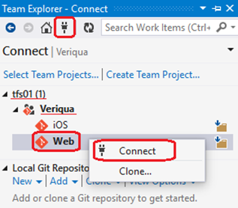

If the repository isn’t cloned already under **Solutions** section, click **Clone Repository**. This will bring up a **Clone** **Repository** section at the top of the **Team** **Explorer** window as seen in the screenshot below.

You can provide a different **local path in the second text field** before hitting the **Clone** button to begin downloading all the source files.

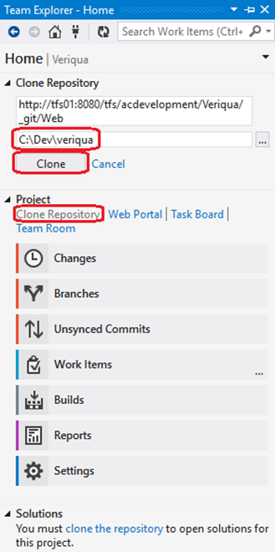

Once you have a successfully cloned local repository, you can **double click** **your project name** in the **Solutions** section at the bottom of the **Home** tab to open the **solution**.

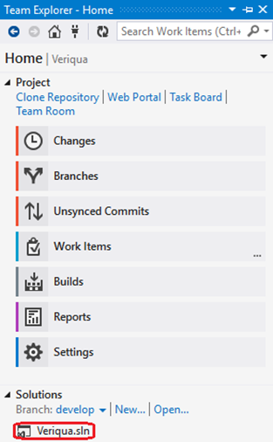

### Method 2: CLI (Command Line Interface)

You can get the latest source code by running the following **CLI** (Command Line Interface) command within the directory you would like it to be placed, using the information below it:

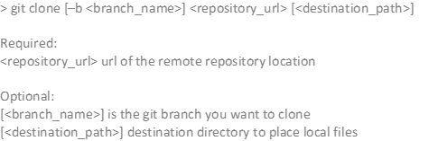

* Repository URL: <http://tfs01:8080/tfs/ACDevelopment/[ProjectName]/_git/[Subfolder> or repository name] which you can find the exact URL by opening our TFS webpage at <http://tfs01:8080/tfs/>, browse to the project, navigate to the **Code** menu item, and click **Clone** on the right-hand side and copy the URL. 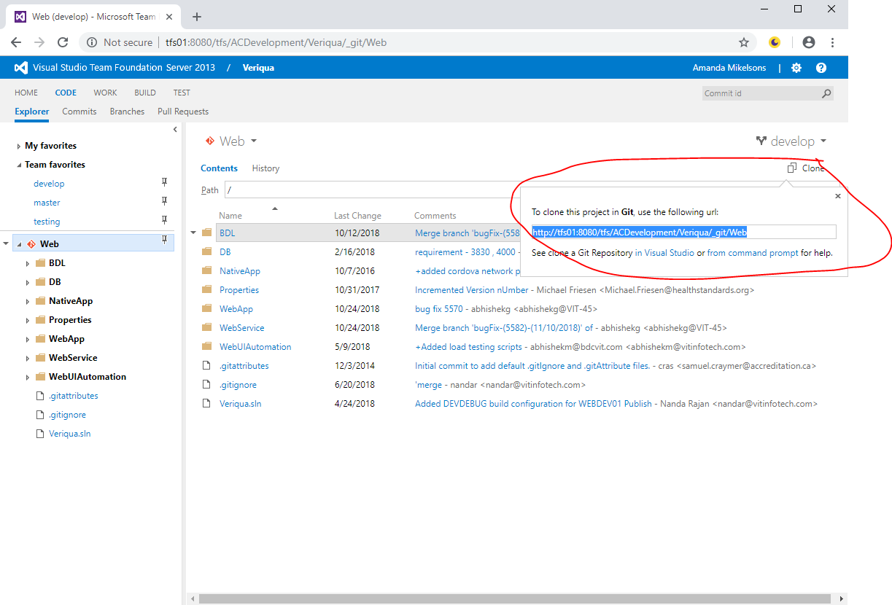

Next, open up the newly created folder and you should see the **[ProjectName].sln** file located in the root directory which you can open in **Visual** **Studio**.

## Synchronizing your code

When synchronizing your code (from your local repository with the remote (server) repository), for most of our projects (especially when there are two or more internal developers) we should use the “**Sync**” feature. This ensures both that you get other people’s changes as well as pushing your own your own (versus just doing a **Push** or **Pull**). **Sync** will merge both incoming and outgoing changes, and prompt you to review and merge any conflicts.

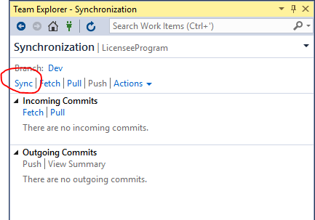

On the other hand, if there are external consultants working on the project or one developer who is designated to review another’s work, it may be more appropriate for the developer to submit their changes via **Pull Requests**, and one developer to review them.

## Branching

Each new feature should have its own branch, so that when ready it can be launched independently of other features (ie. not needing to wait on other features, or if it is decided not to launch another feature). Put these under branches under a folder called **Features, or Hotfix** for hotfixes.

The branch for each new feature should be taken from **master**. That way, the feature can be launched without including any other changes that are present in dev branch but not on master.

